**MINISTRY OF EDUCATION AND TRAINING**

**HCMC UNIVERSITY OF TECHNOLOGY AND EDUCATION**

**FACULTY FOR HIGH-QUALITY TRAINING**



Final Project

Restaurant Management System

Course: Windows Programming

Period: T5 (7 – 10)

Lecturer: Le Vinh Thinh

|  |  |
| --- | --- |
| **NAME** | **STUDENT’S ID** |
| Le Minh Thang | 18110048 |
| Nguyen Tan Thanh | 18110046 |

*HCMC June, 2021  
Last update: June 2, 2021*

**SCORE**

|  |  |  |  |
| --- | --- | --- | --- |
| Criteria | Content | Presentation | Total |
| Point |  |  |  |

**REMARKS OF TEACHERS**

………………………………………………………………………………………………………………………………………………………………….

…………………………………………………………………………………………………………………………………………………………………

…………………………………………………………………………………………………………………………………………………………………

…………………………………………………………………………………………………………………………………………………………………

…………………………………………………………………………………………………………………………………………………………………

Ho Chi Minh City, June 2h, 2021

Teacher’s score

(Signature and full name)

**Le Vinh Thinh**

**THANK YOU**

In order to successfully complete this topic and this report, we would like to extend our sincere thanks to the lecturer, Dr. Le Vinh Thinh, who directly supported us throughout the process of making the topic. We thank the teacher for giving advice from his practical experience to guide us in the right direction with the requirements of the selected topic, always answer questions and give suggestions and corrections. time to help us overcome our shortcomings and complete it well as well as on schedule.

We also would like to express our sincere thanks to the teachers in the

High Quality Education Department in general and the Information Technology industry in particular for their dedicated knowledge to help us have a foundation to make. This topic has created conditions for us to learn and perform well on the topic. Along with that, we would like to thank our classmates for providing useful information and knowledge to help us improve our topic.

The topic and report are made by us in a short time, with limited knowledge and many other limitations in terms of technical and experience in implementing a software project. Therefore, in the process of creating a topic with shortcomings is inevitable, we look forward to receiving valuable comments from the teachers to make our knowledge more complete and We can do even better next time.

We sincerely thank you.

At the end, we would like to wish all of you teachers, ladies and gentlemen, always having abundant health and more success in the career of growing people. Once again we sincerely thanks.

**SUBJECT DESCRIPTION OF THE SUBJECTS WINDOWS PROGRAMING**

Implementing student: **Le Minh Thang** ID’s student: **18110048**

Implementing student: **Nguyen Tan Thanh** ID’s student: **18110046**

Field: **Information Technology**

Name’s project: **Restaurant Management System**

Instructor: **Dr. Le Vinh Thinh**

**Tasks of the topic:** Building a program that working like restaurant serving in morning, afternoon and evening. The program must consist of :

1. Manage employee and their information.

2. Working shift and wages for employee.

3. Customer Information.

4. Kitchen, Food and Ingredient Information.

5. Booking Table and Invoice List Information.

**TABLE OF CONTENTS**

**table Image list** 7

**i.General** 8

**iI.content** 9

**iII.Interface design** 11

**iV. conClude** 20

*All images which are presented in this report are listed here.*

|  |
| --- |
| **table Image list** |
|  |

|  |  |  |
| --- | --- | --- |
| Figure | Caption | Page |
| 1.1.2 | Database Diagram | 10 |
| 3.1 | Login Form | 11 |
| 3.2 | Main Form | 11 |
| 3.3 | Checking Working Hours Form | 13 |
| 3.4 | Staff Form | 13 |
| 3.5 | Customer And Table Form | 17 |
| 3.6 | Food Form | 21 |
| 3.7 | Customer Login Form | 25 |

**i.General**

**1. SYSTEM ANALYSIS AND DESIGN**

**- Basic:**

+ User (add, edit, delete)

+ QLNV (add, edit, delete, search list)

+ Diemdanh (add, edit, delete, list, search) for Manager and only add for staff,chef.

+ Ban (add, delete, edit)

+ Datmon (add, cancel, edit, list by table, change quantity when order food)

+ Hoadon (only create when the meal are already paid by customer)

**State 1: Staff management**

**-** Management of shift working:

1. Shift working for: manager, cheft, staff in one day.

We have 3 shift: 7g—11g; 11h—2g; 6g-10g. Staff or all position who come first will have the first working shift.

2. Some Detail Information:

Only have two manager, N staff. Two manager can not working in same working shift.

Time working: 8h/per day. Wage 50k/h.

At 10:05 pm each day. Program must announce the wages for each staff.

3. Wage detail:

a. Wage:

Staff who have working enough 8 hours will have 50k/h.

b. Fines:

i. Each one hours less than will be fined 100k.

ii. Who replace for that employee with one hours will have 100k bonus. Maximum time for working replace are 4 hours.

**State 2:**

- Management of customer, kitchen and booking table

+ Manager will import the ingredient each days. The chef in kitchen will have tools to calculate the total number of each food they can sell in that day. At the end of day, manager can watch the chart summary total amount of each food they have sell in one day also in each table to see if there is any problem occurs.

+ Manager also have the chart the total most sell food in one month and the income they gain in one day to calculate for their business.

+ When the customer finish and paid their meal, the program will automatically sell their invoice to prevent if any problem occurs.

**iI.content**

1. **DATABASE DESIGN**
   1. **Create databases**
      1. **Description of Tables**

|  |  |  |
| --- | --- | --- |
| **No** | **Table’s name** | **Purpose** |
| 1 | User | - Store all account of manager, chef and employee. |
| 2 | QLNV | - Store all information of all manager, chef and employee. |
| 3 | Diemdanh | - Store date time for checking attendance of all human resources. |
| 4 | Ban | - Store table information when customer booking |
| 5 | Khachhang | - Store customer information |
| 6 | Datmon | - Contains information when customer selecting food |
| 7 | Hoadon | - Contains information like cost,... and time when they finish paying meal. |
| 8 | Food | - Store all food information. |
| 9 | NguyenLieu | - Store all ingredient to make food. |

* + 1. **Database Diagram**

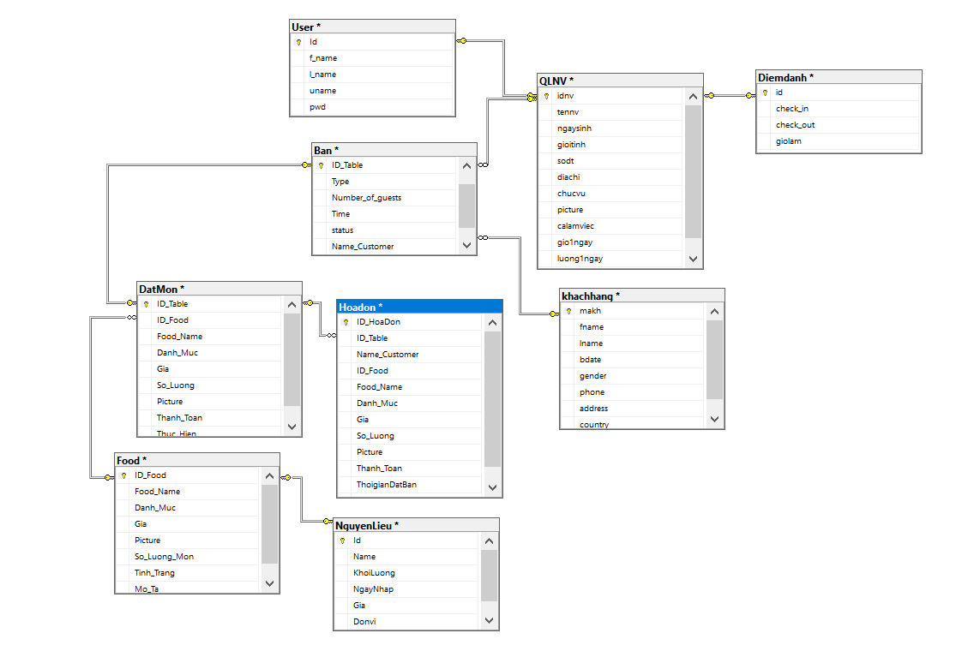

Figure 1.1.2 Database Diagram

**iII.Interface design**

1. **Login Form**

We have 3 roles here to login: Manager, Chef, Staff.

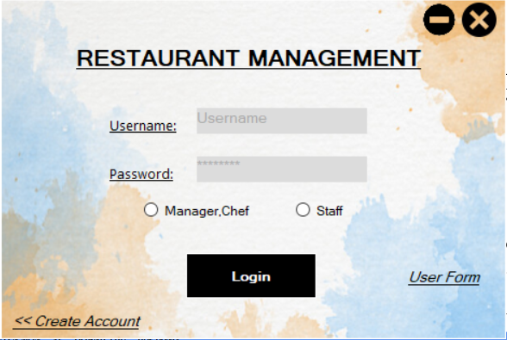

1. **Main Form**

The Main Form is the main page for navigating to the restaurant system. Chef will have the same main form as manager to check working time and manage food but absolutely prohibit many function.

+ Main Form for Manager:

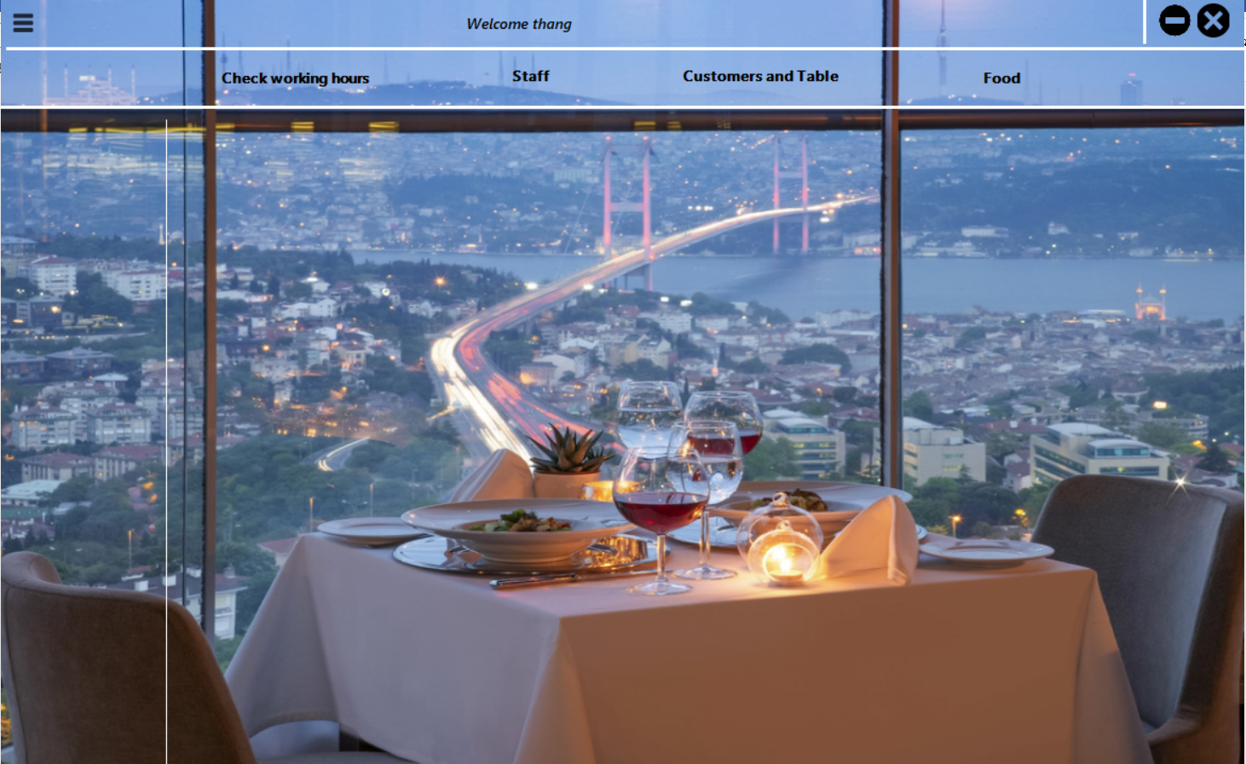

+ Main Form for Chef:

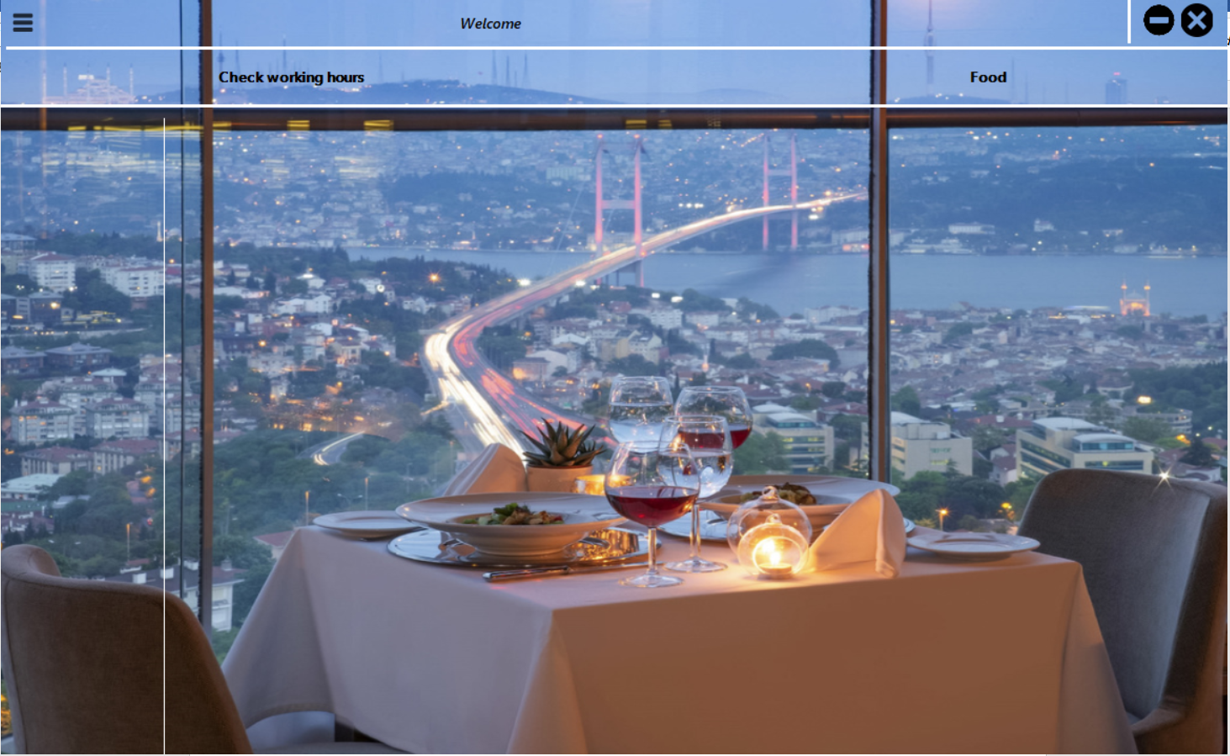

+ Main Form for Employee: Only have to use checking attendance.

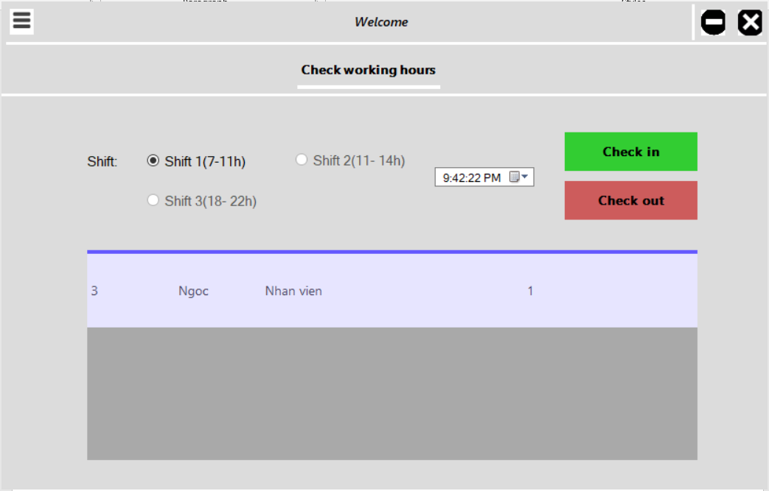

1. **Checking Working Hours Form:** Similar to chef.

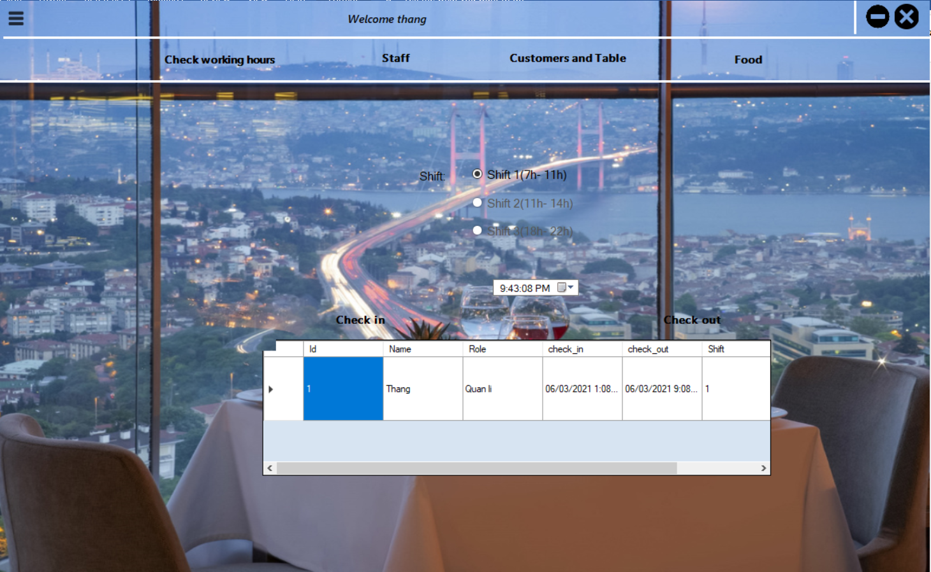

Figure 3.1.Main Form

1. **Staff Form:** Staff Form only for manager manage it.

**+ Staff Management Form:** When new user has been added by Manager here, program will create account for them by their role (username: their role+their id, password: 123) and also provide the working shift for them in one day.

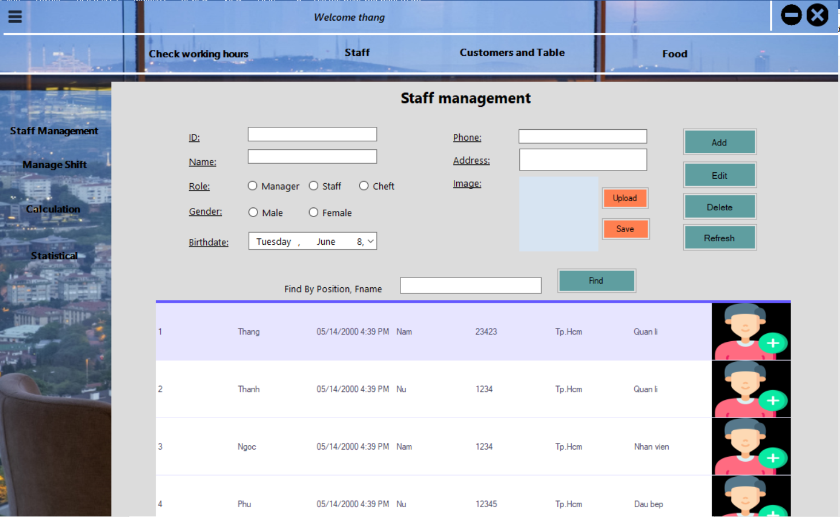

I have add the new chef user and id is 5 so account for this chef is :

Username: chef5 password:123

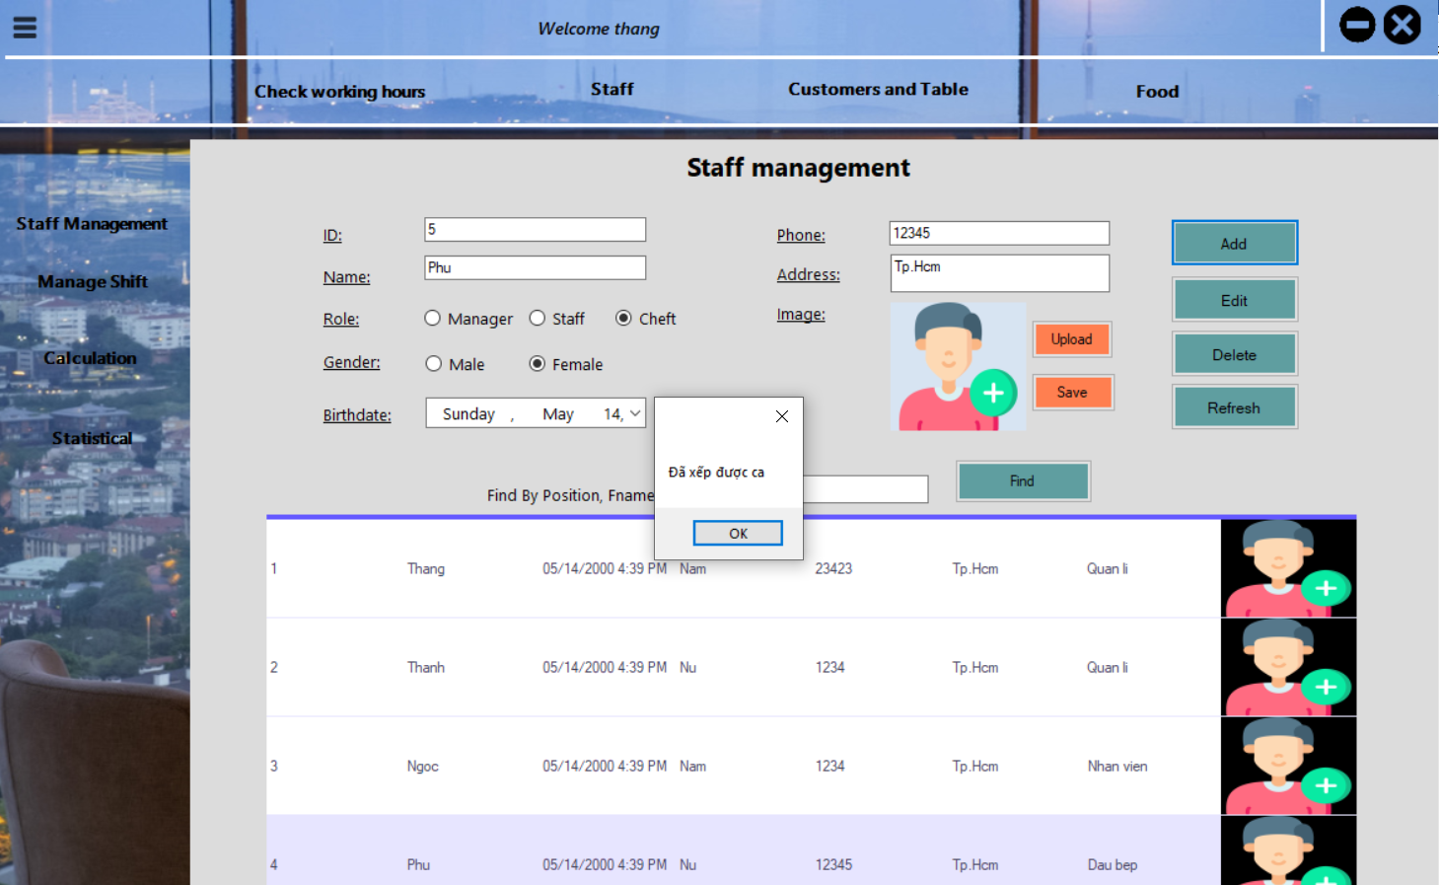

Figure 4.1. Staff Management Form

**+ Manage Shift Form:** For employee want to change working shift. Manager can use this form to do it by handwork.

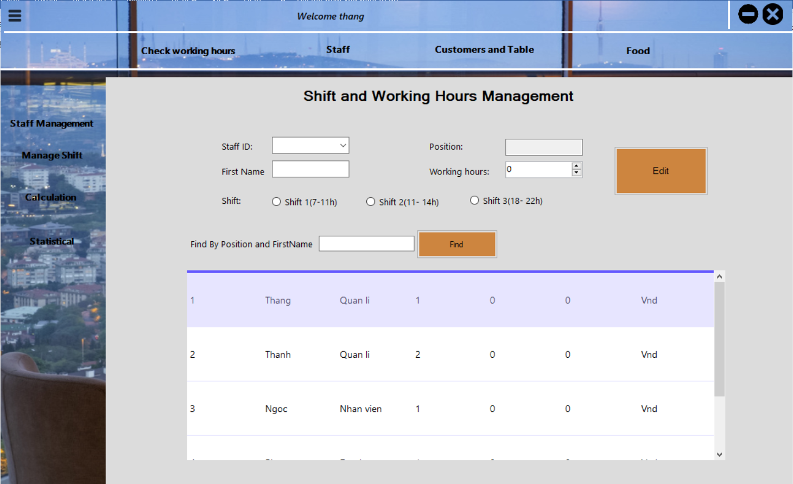

Figure 4.2. Manage Shift Form

**+ Calculation and Statistical Form:** Salary by working hours for each employee.

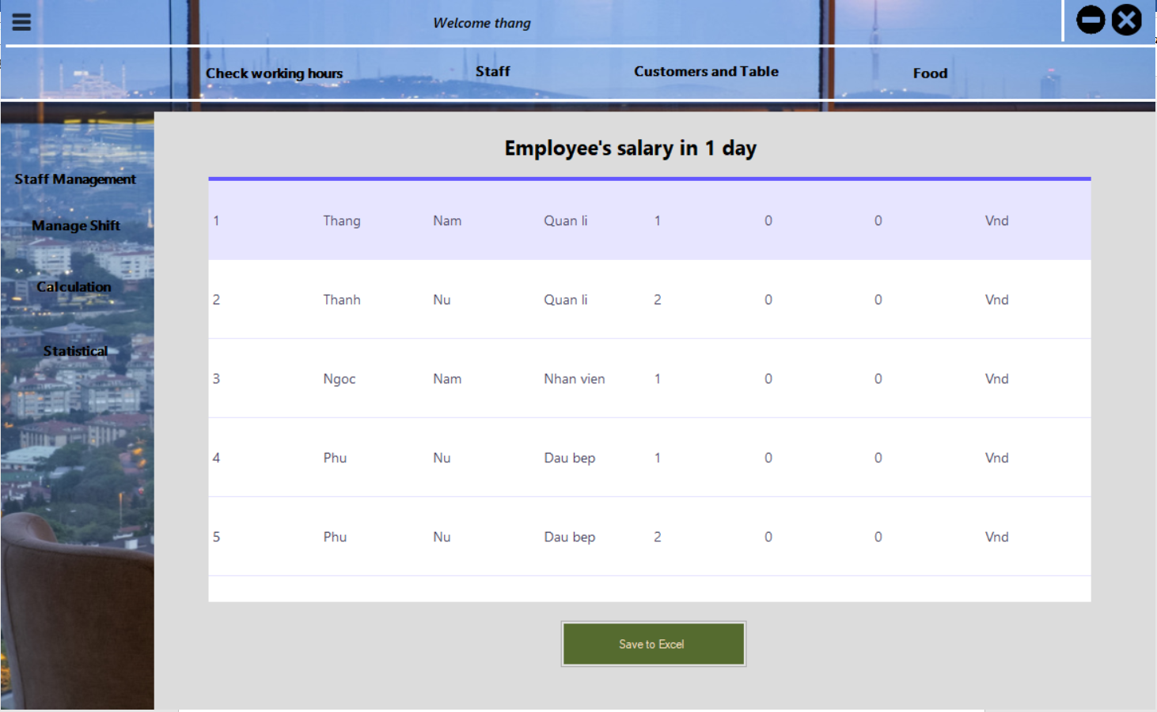

Figure 4.3. Calculation Form

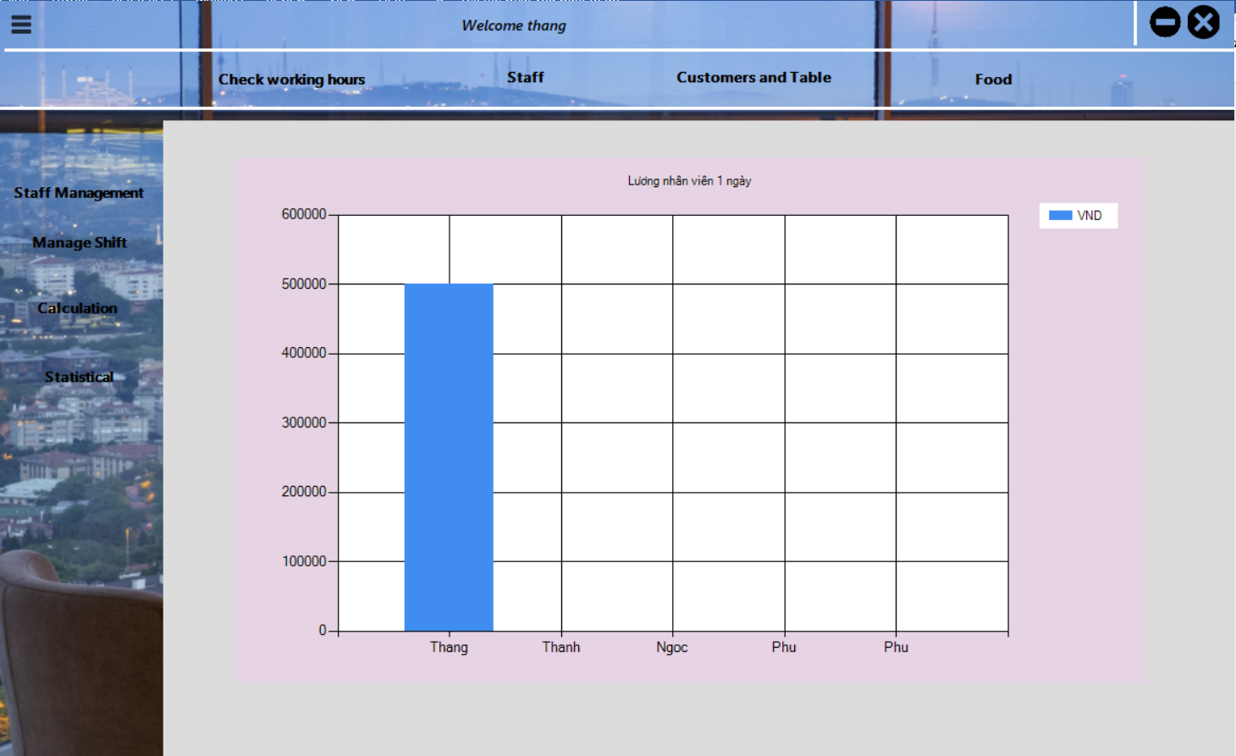

Figure 4.4. Statistical Form

1. **Customer and Table Form:** this function also only for manager account.

**+ Customer management Form:** Management Customer Information.

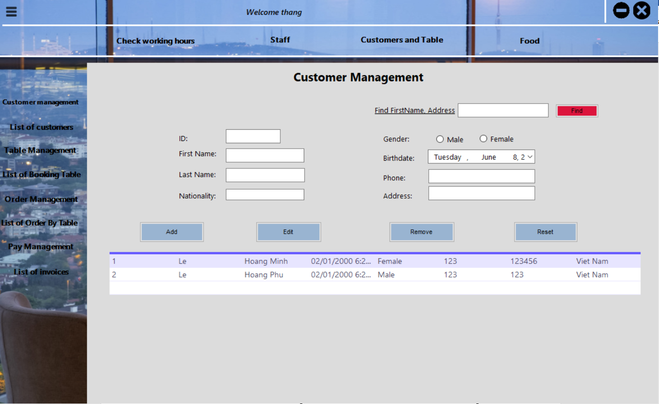

Figure 5.1. Customer Management Form

**+ List Of Customers Form:** List of All Existing Customer

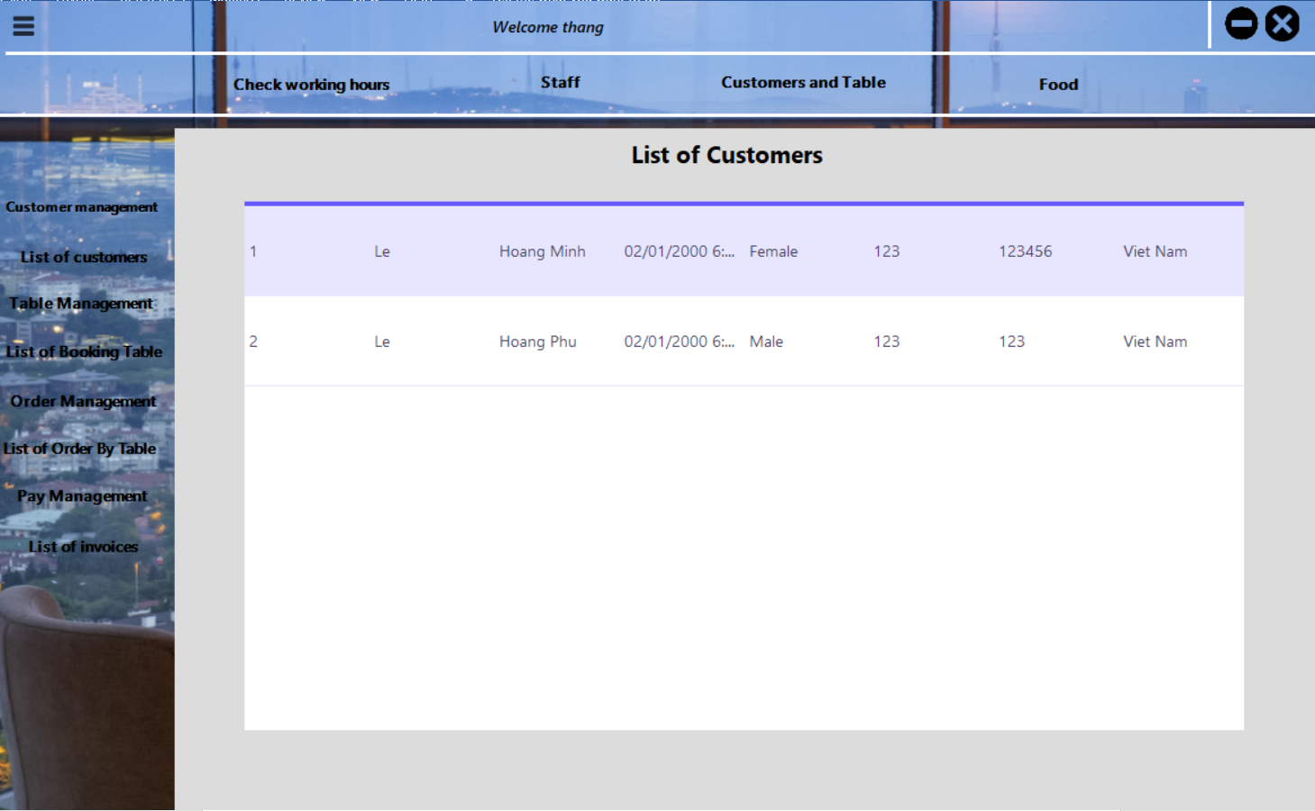

Figure 5.2. List Of Customers Form

**+ Table Management Form:** Table which has been booked will have color in the background.

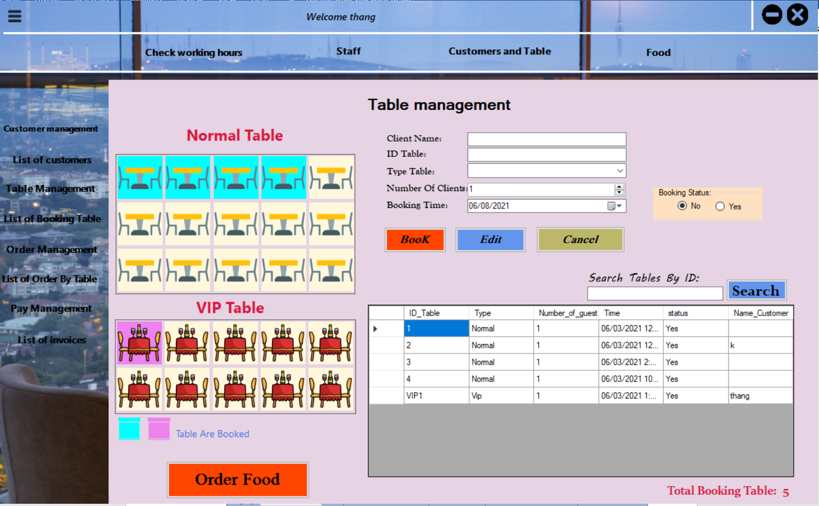

Figure 5.3. Table Management Form

**+ Booking Table List Form:** List all table are being booked now.

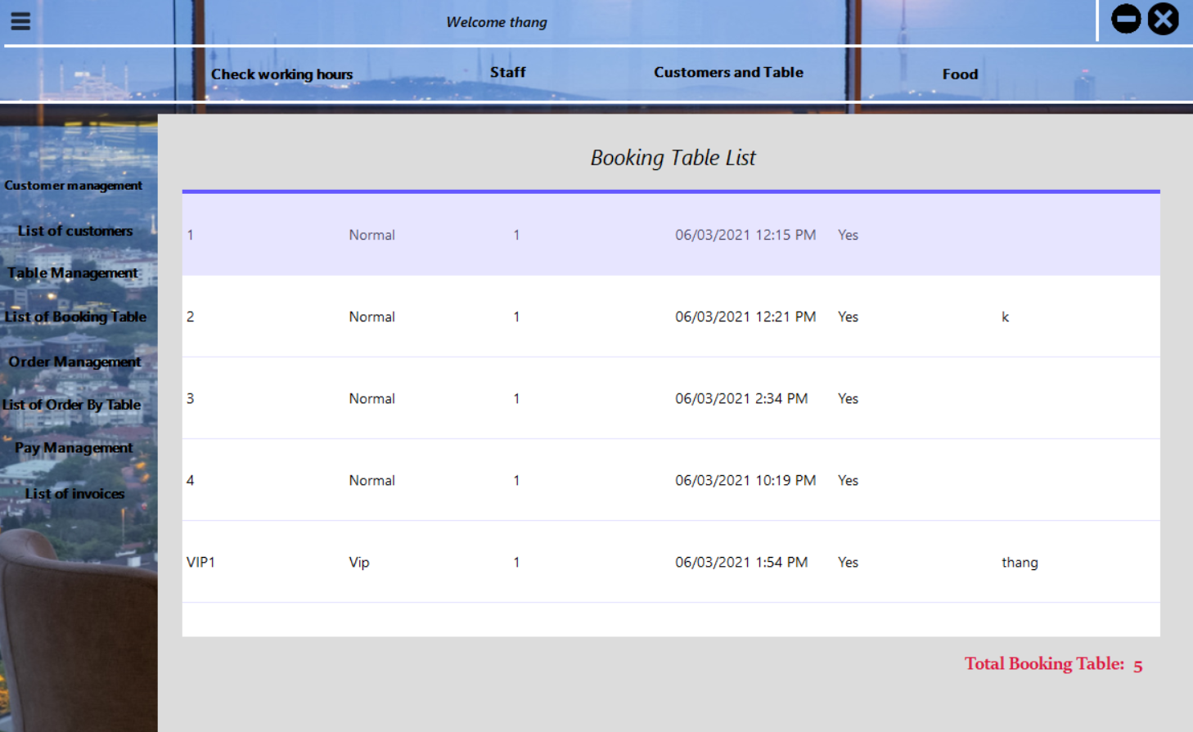

Figure 5.4. List Of Booking Table Form

**+ Order Management Form:** This form here will use to manage the order of customer (select dishes, change number amount dishes or cancel order).

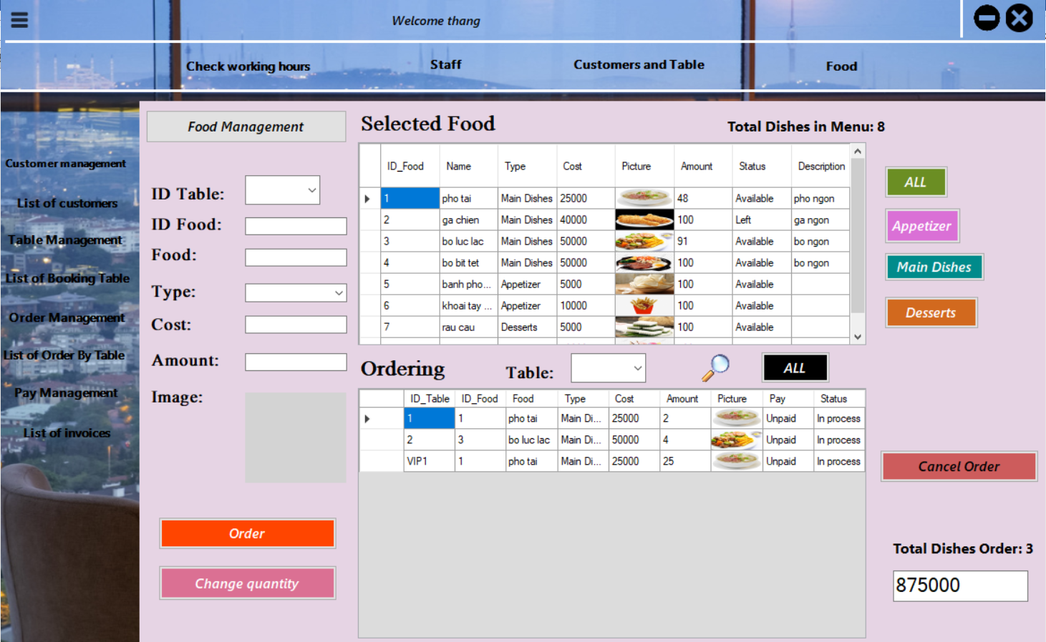

Figure 5.5. Order Management Form

**+ List Of Order By Table Form:** This form here will use for manager to watch dishes in specific booking table.

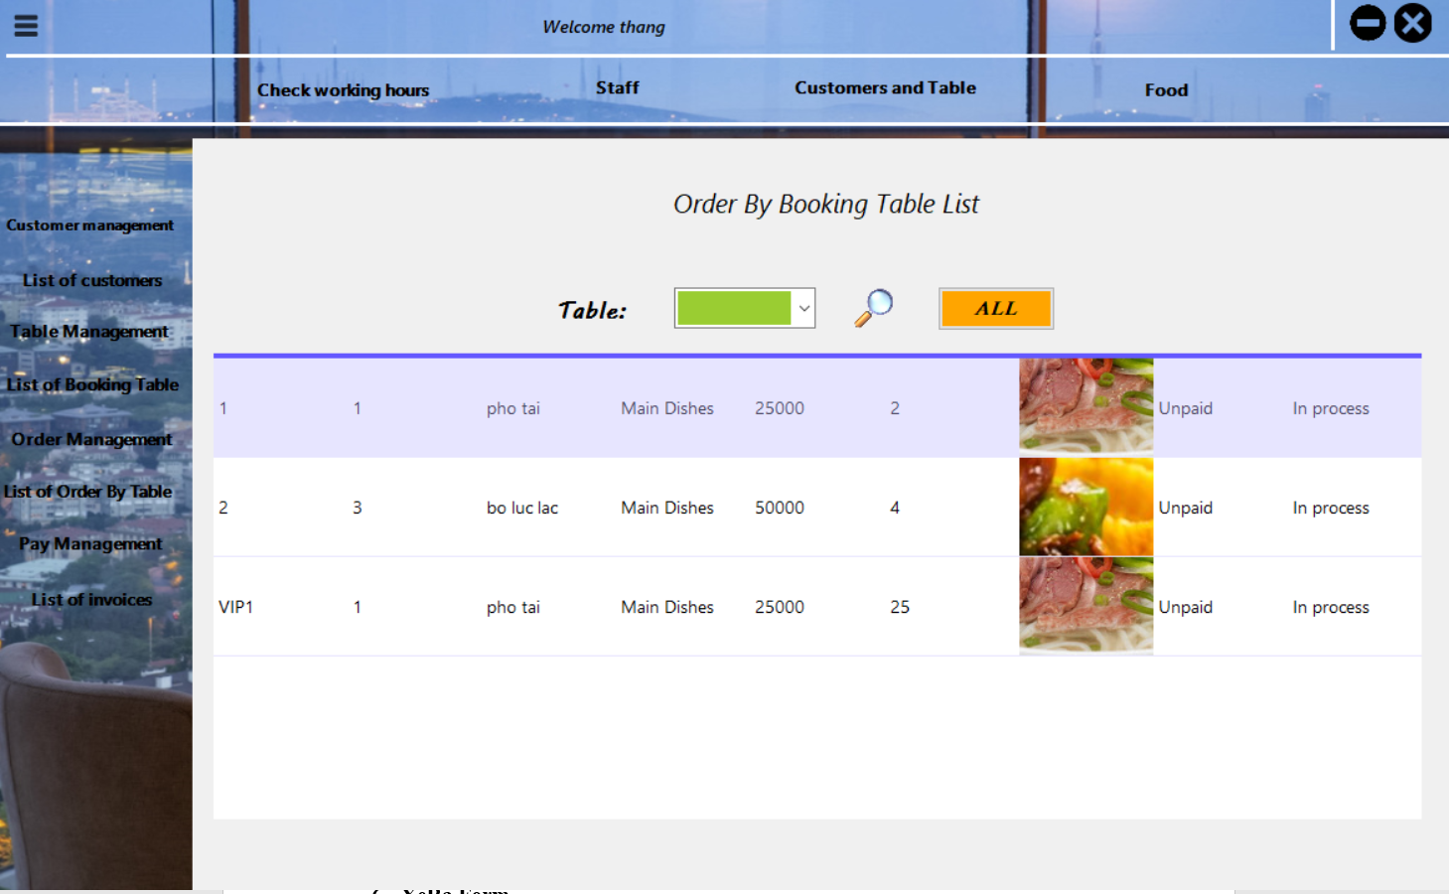

Figure 5.6. List Of Order By Table Form

**+ Payment Form:** After finishing their meal, the total cost the customer must be paid can be done in here.

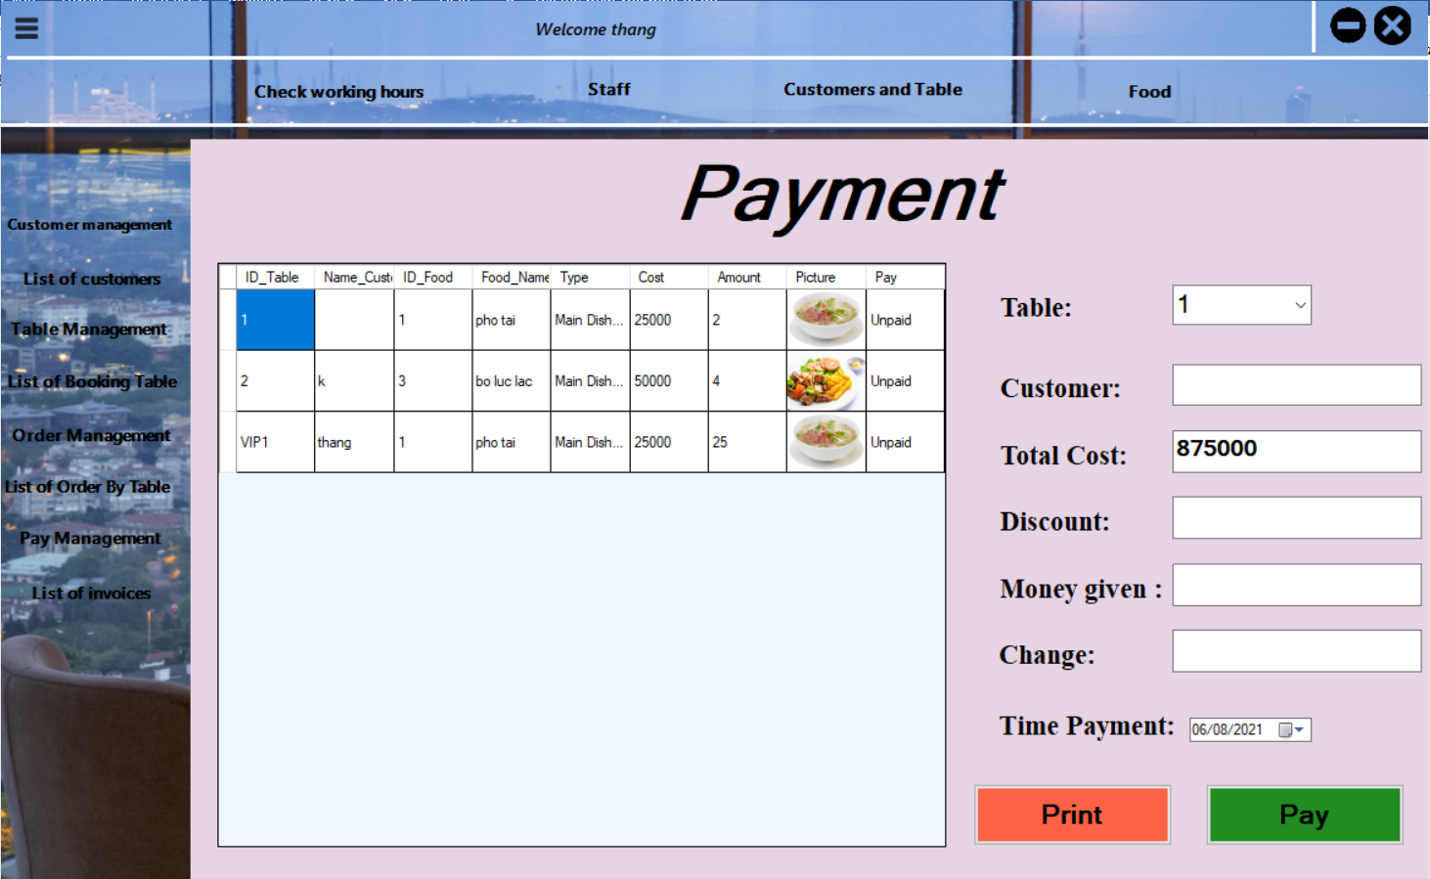

Figure 5.7. Payment Form

**+ List Of Invoices Form:** When the customer finish their paying. Their invoices will be stored in here.

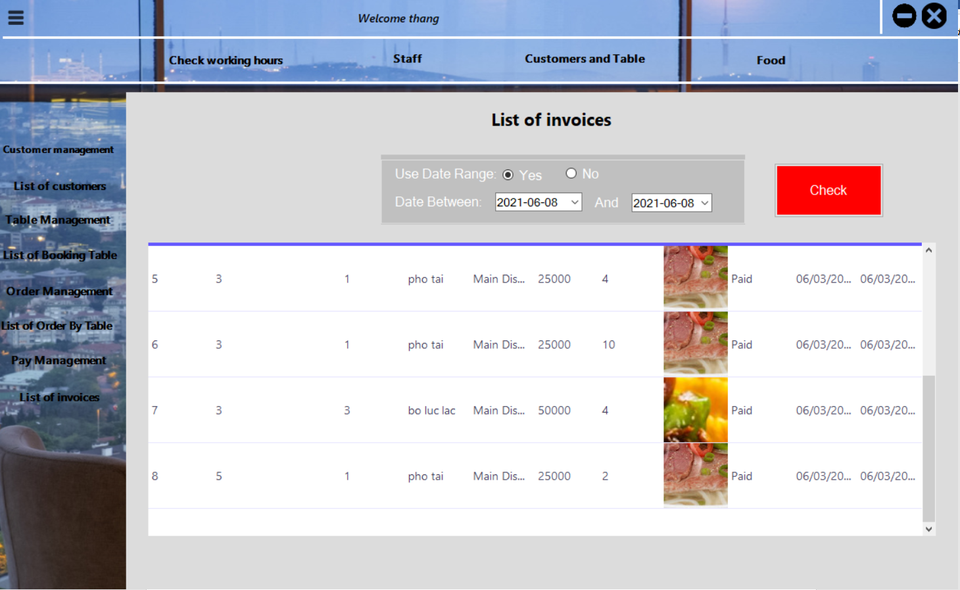

Figure 5.8. List Of Invoices Form

1. **Food Form:**

For Manager to import the ingredient and view the static number of each food and their income each day.

For the Chef, they only can see the ingredient then calculate the total amount of each food for one day. They also manage the kitchen when finish the food can announce to the manager to call the staff or status of the food.

**+ Food Management Form:** This form is the food have in the restaurant. This datagridview will be show as the menu for the customer to select.

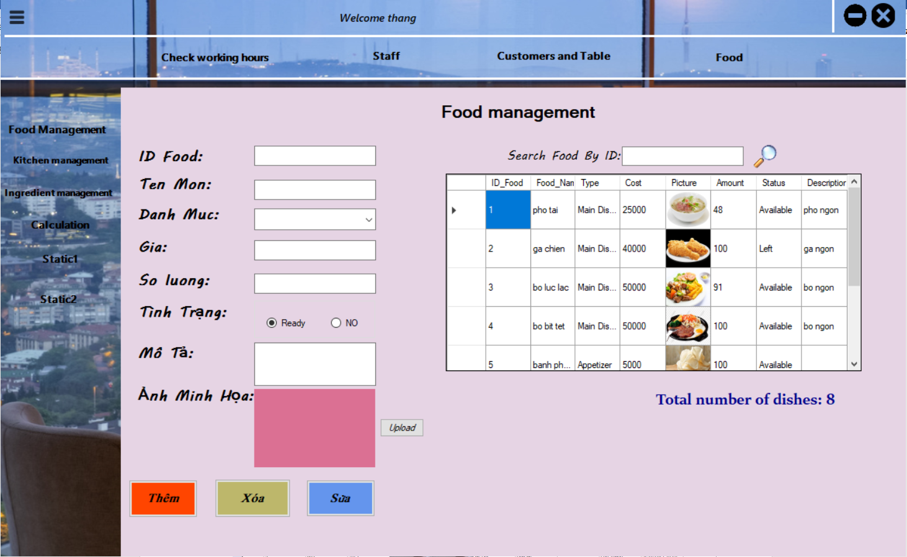

Figure 6.1. Food Management Form

**+ Kitchen Management Form:** This form is for the Chef. If they have finish cooking, they can change the status finish to serve to customer. If the food have any problems, they can change the dish status to announce it.

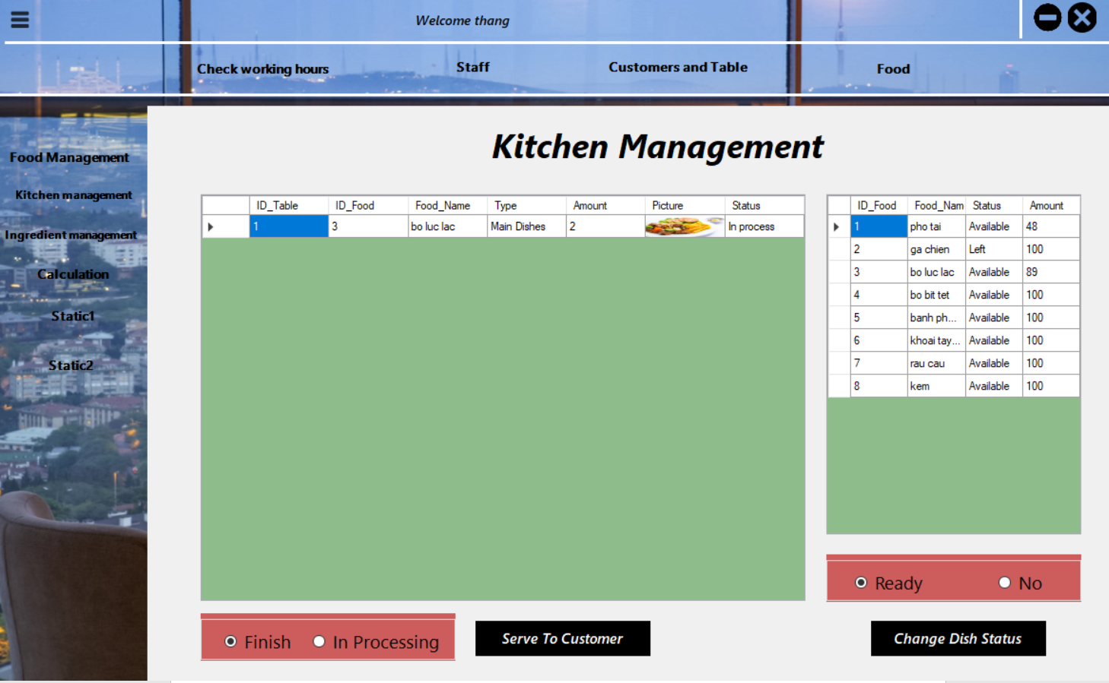

Figure 6.2. Food Management Form

**+ Ingredient Management Form:** This form is for the Manager. They will import each day for the chef to cook.

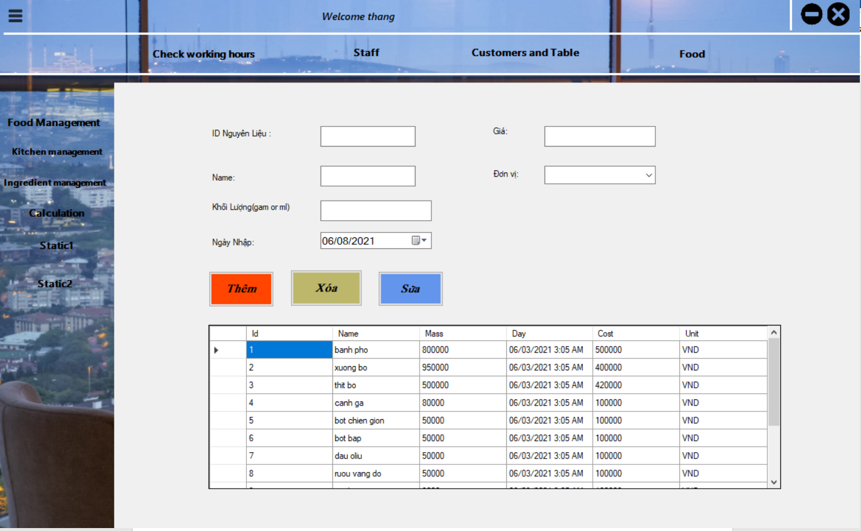

Figure 6.3. Ingredient Management Form

**+ Calculation Form:** This form is for chef. They can depend on the ingredient to calculate the number of each dishe they can cook in that day.

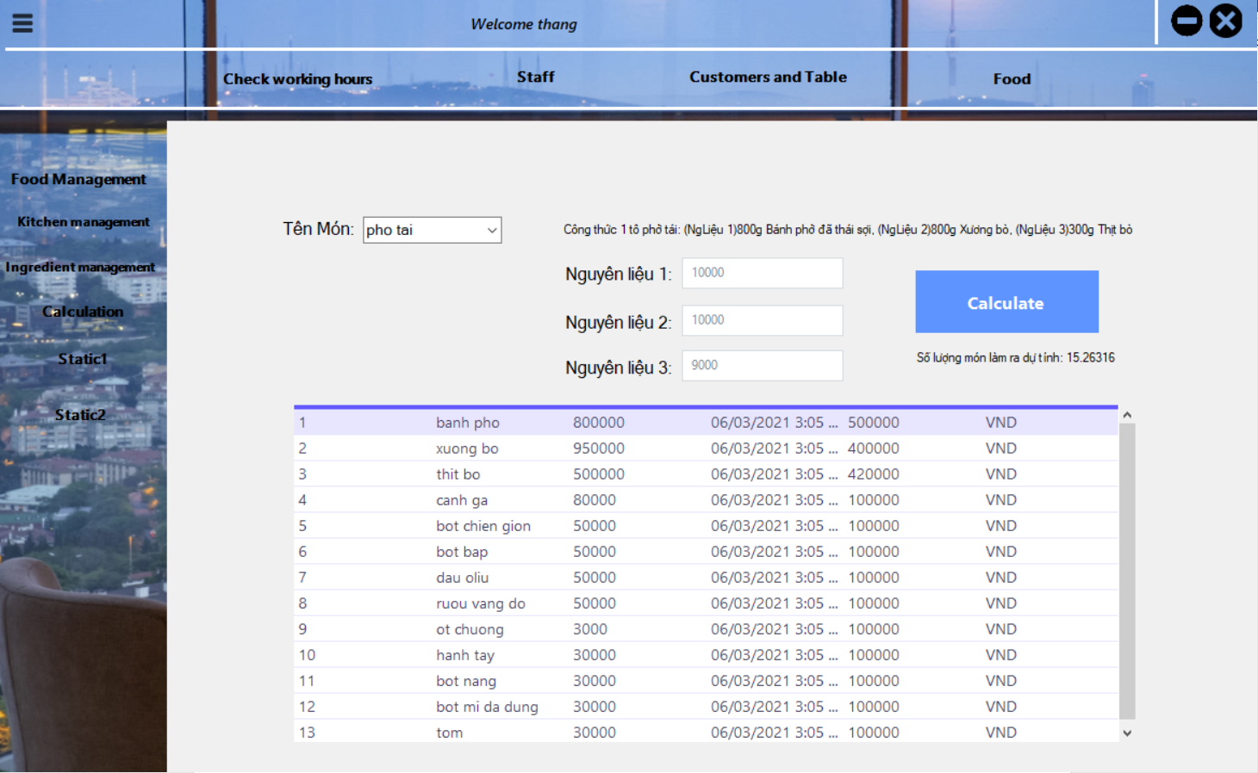

Figure 6.4. Calculation Form

**+ Static1 and Stactic2 Form:** These Form are for manager, if we login as chef we can not view this.

+ Static1 form is the total food have been sold in each table in one day and also the income they get.

+ Static2 form is the total number of food they sold in one day and in one month.

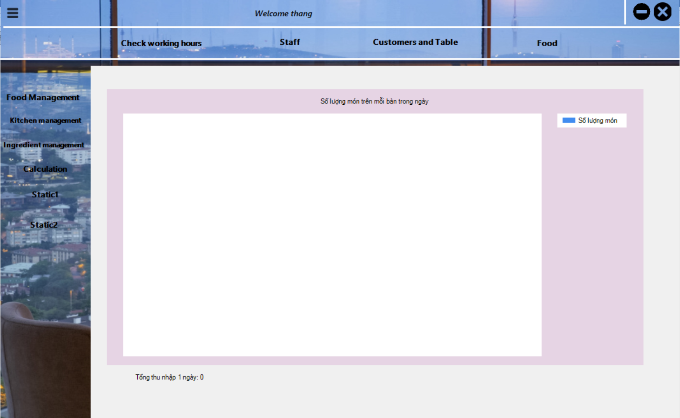

Figure 6.5. Static1 Form

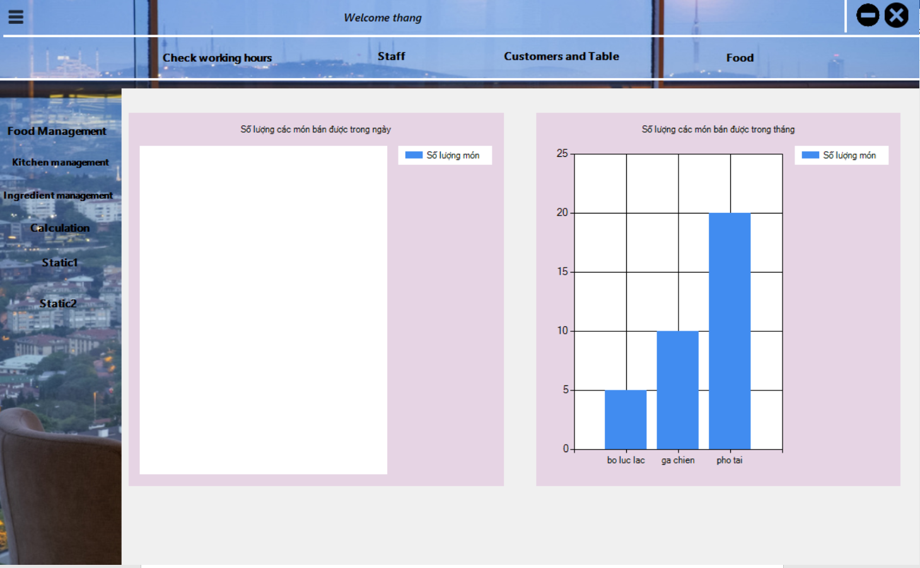

Figure 6.6. Static2 Form

1. **Customer Login**

In Login Form we have the user form to demo for the customer when they go to the restaurant.

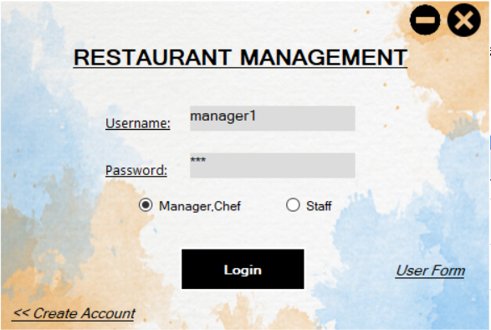

When they go the restaurant, they will book the empty table.

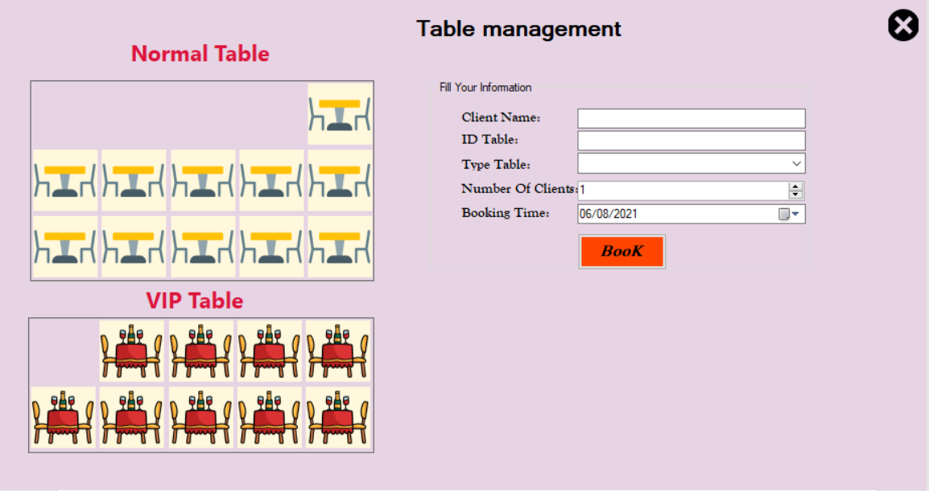

If table are already booking, they will hide so the customer can not select it. Next, the customer will book the empty table to select dishes.

After booking successful, if they want to change table they can cancel this table. If not, they can select the dishes as normal and wait the kitchen finish processing and serve to them.

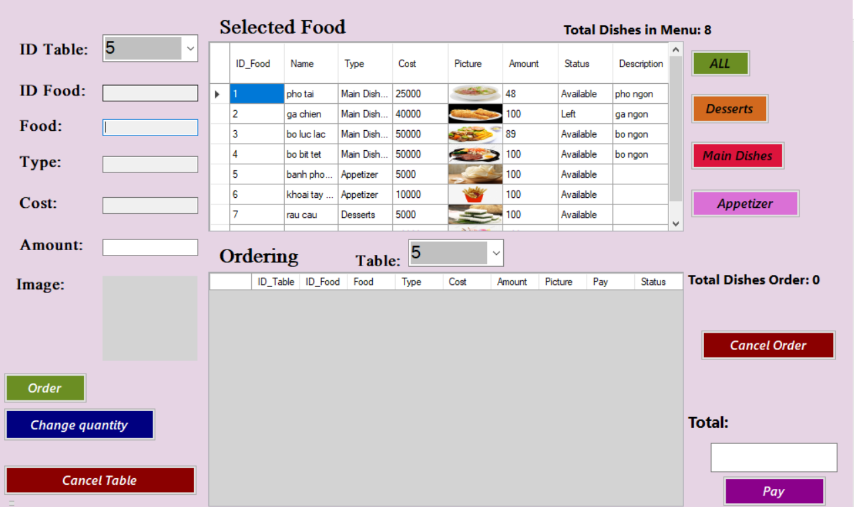

After finish their meal, they can click the button Pay to pay their meal and can leave the restaurant.

**iV. conClude**

Basically, the team self-reviewed that the group's software had solved most of the requirements set out by the project and also added additional useful features to the program.

**Advantages:**

● Clean, intuitive interface, easy to approach, easy to get used to.

● The capacity is quite light.

● The program consumes very little system resources.

● The program runs stably, is tested many times and gives accurate results, no crashes, debug, except or lag during execution to ensure correct user requirements.

**Disadvantages:**

● The algorithm is not optimal when processing many large data streams (Sometimes processing is slow).

● The scheduling working shift for human resources have just only for one day (must to upgrade in one week for more clearly as real-life).

**Toward Development:**

● Add payment feature like smart banking

● Optimized when handling large input data.

● Interface upgrade.

● Add account registration feature.

● Public database on the internet so that it can be accessed from many different machines.